Network Rules

Overall

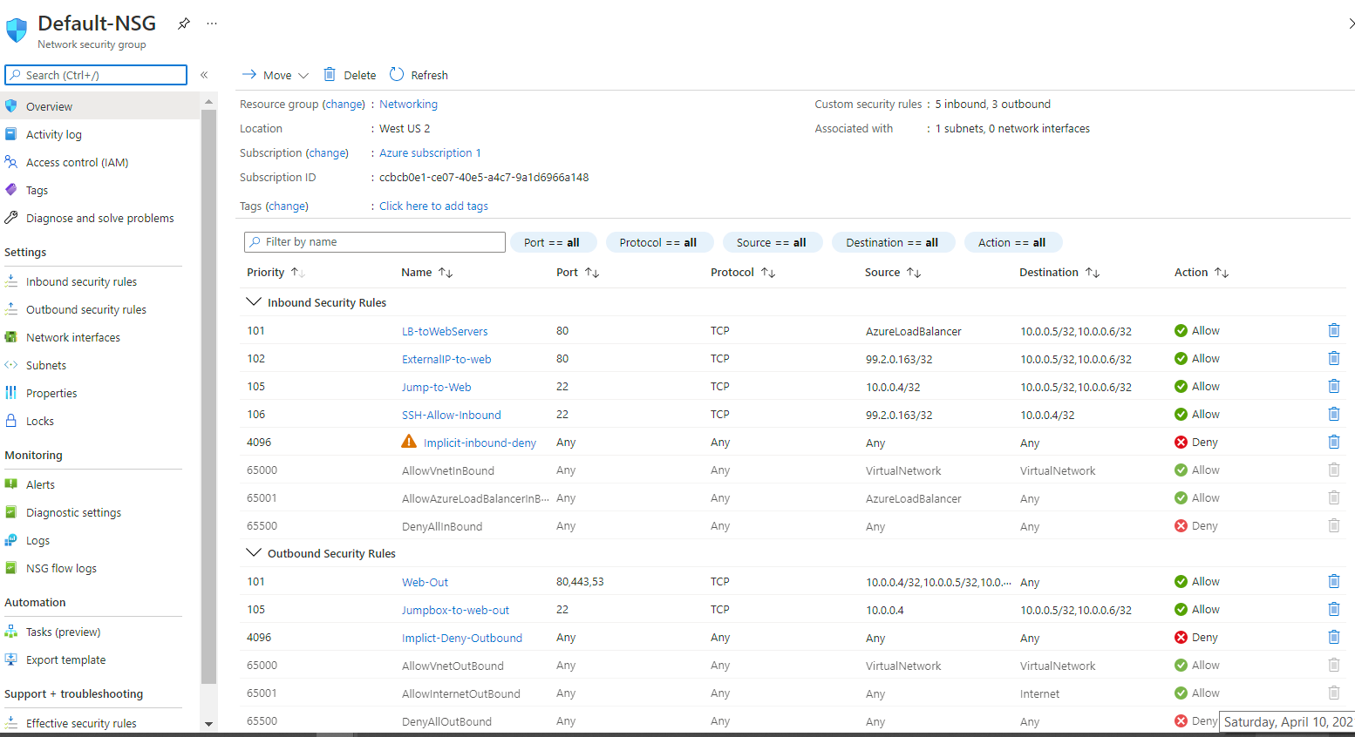

INBOUND

1. Load Balancer to Web Servers

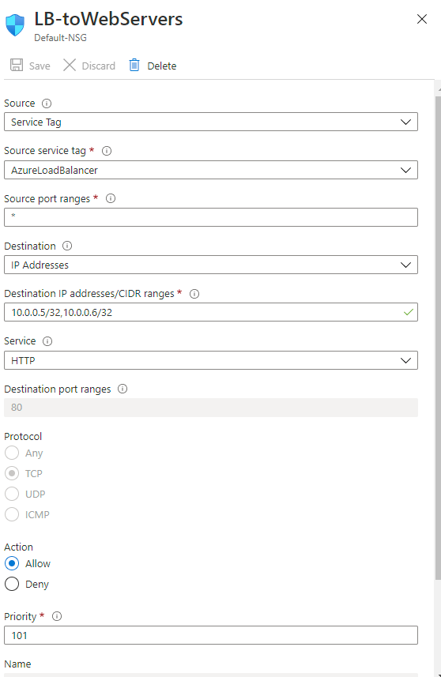

1. Your Home External IP to the Web Servers

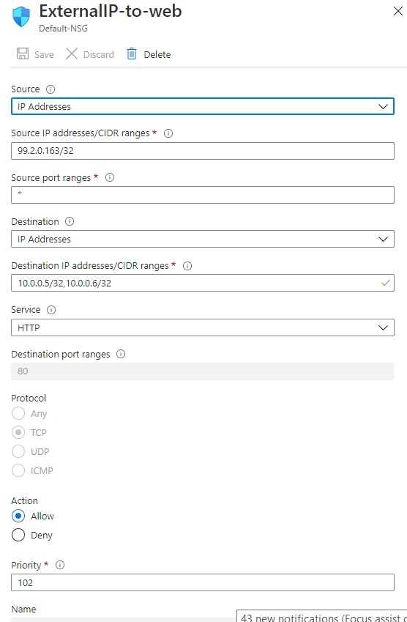

1. Jumpbox can SSH to Web Servers

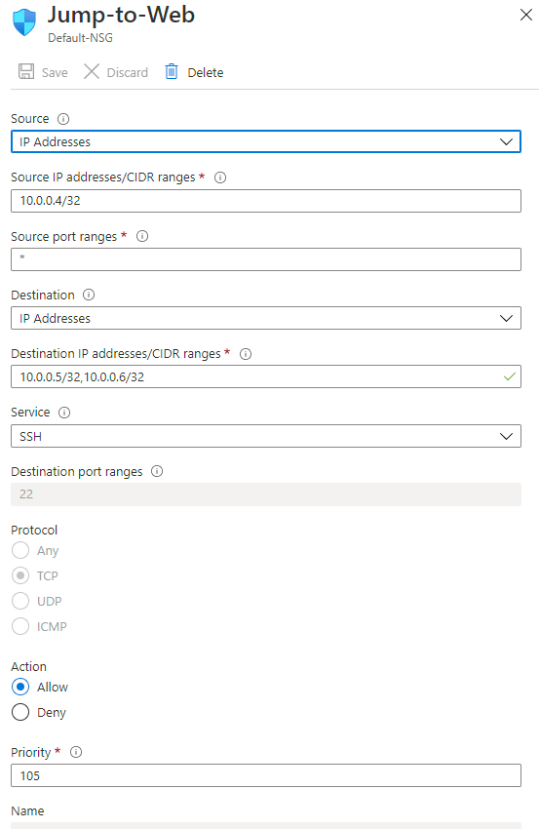

1. SSH from our Home External IP to the JumpBox

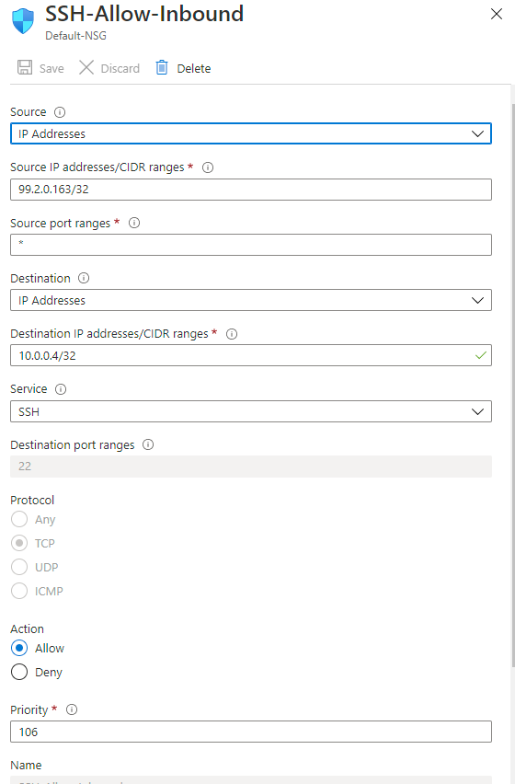

OUTBOUND

1. Allow all servers to communicate out to the web over http,https,dns

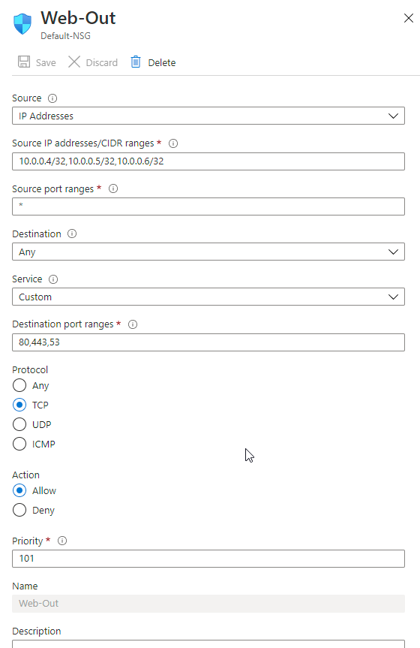

1. Jumpbox to SSH to Web Servers

